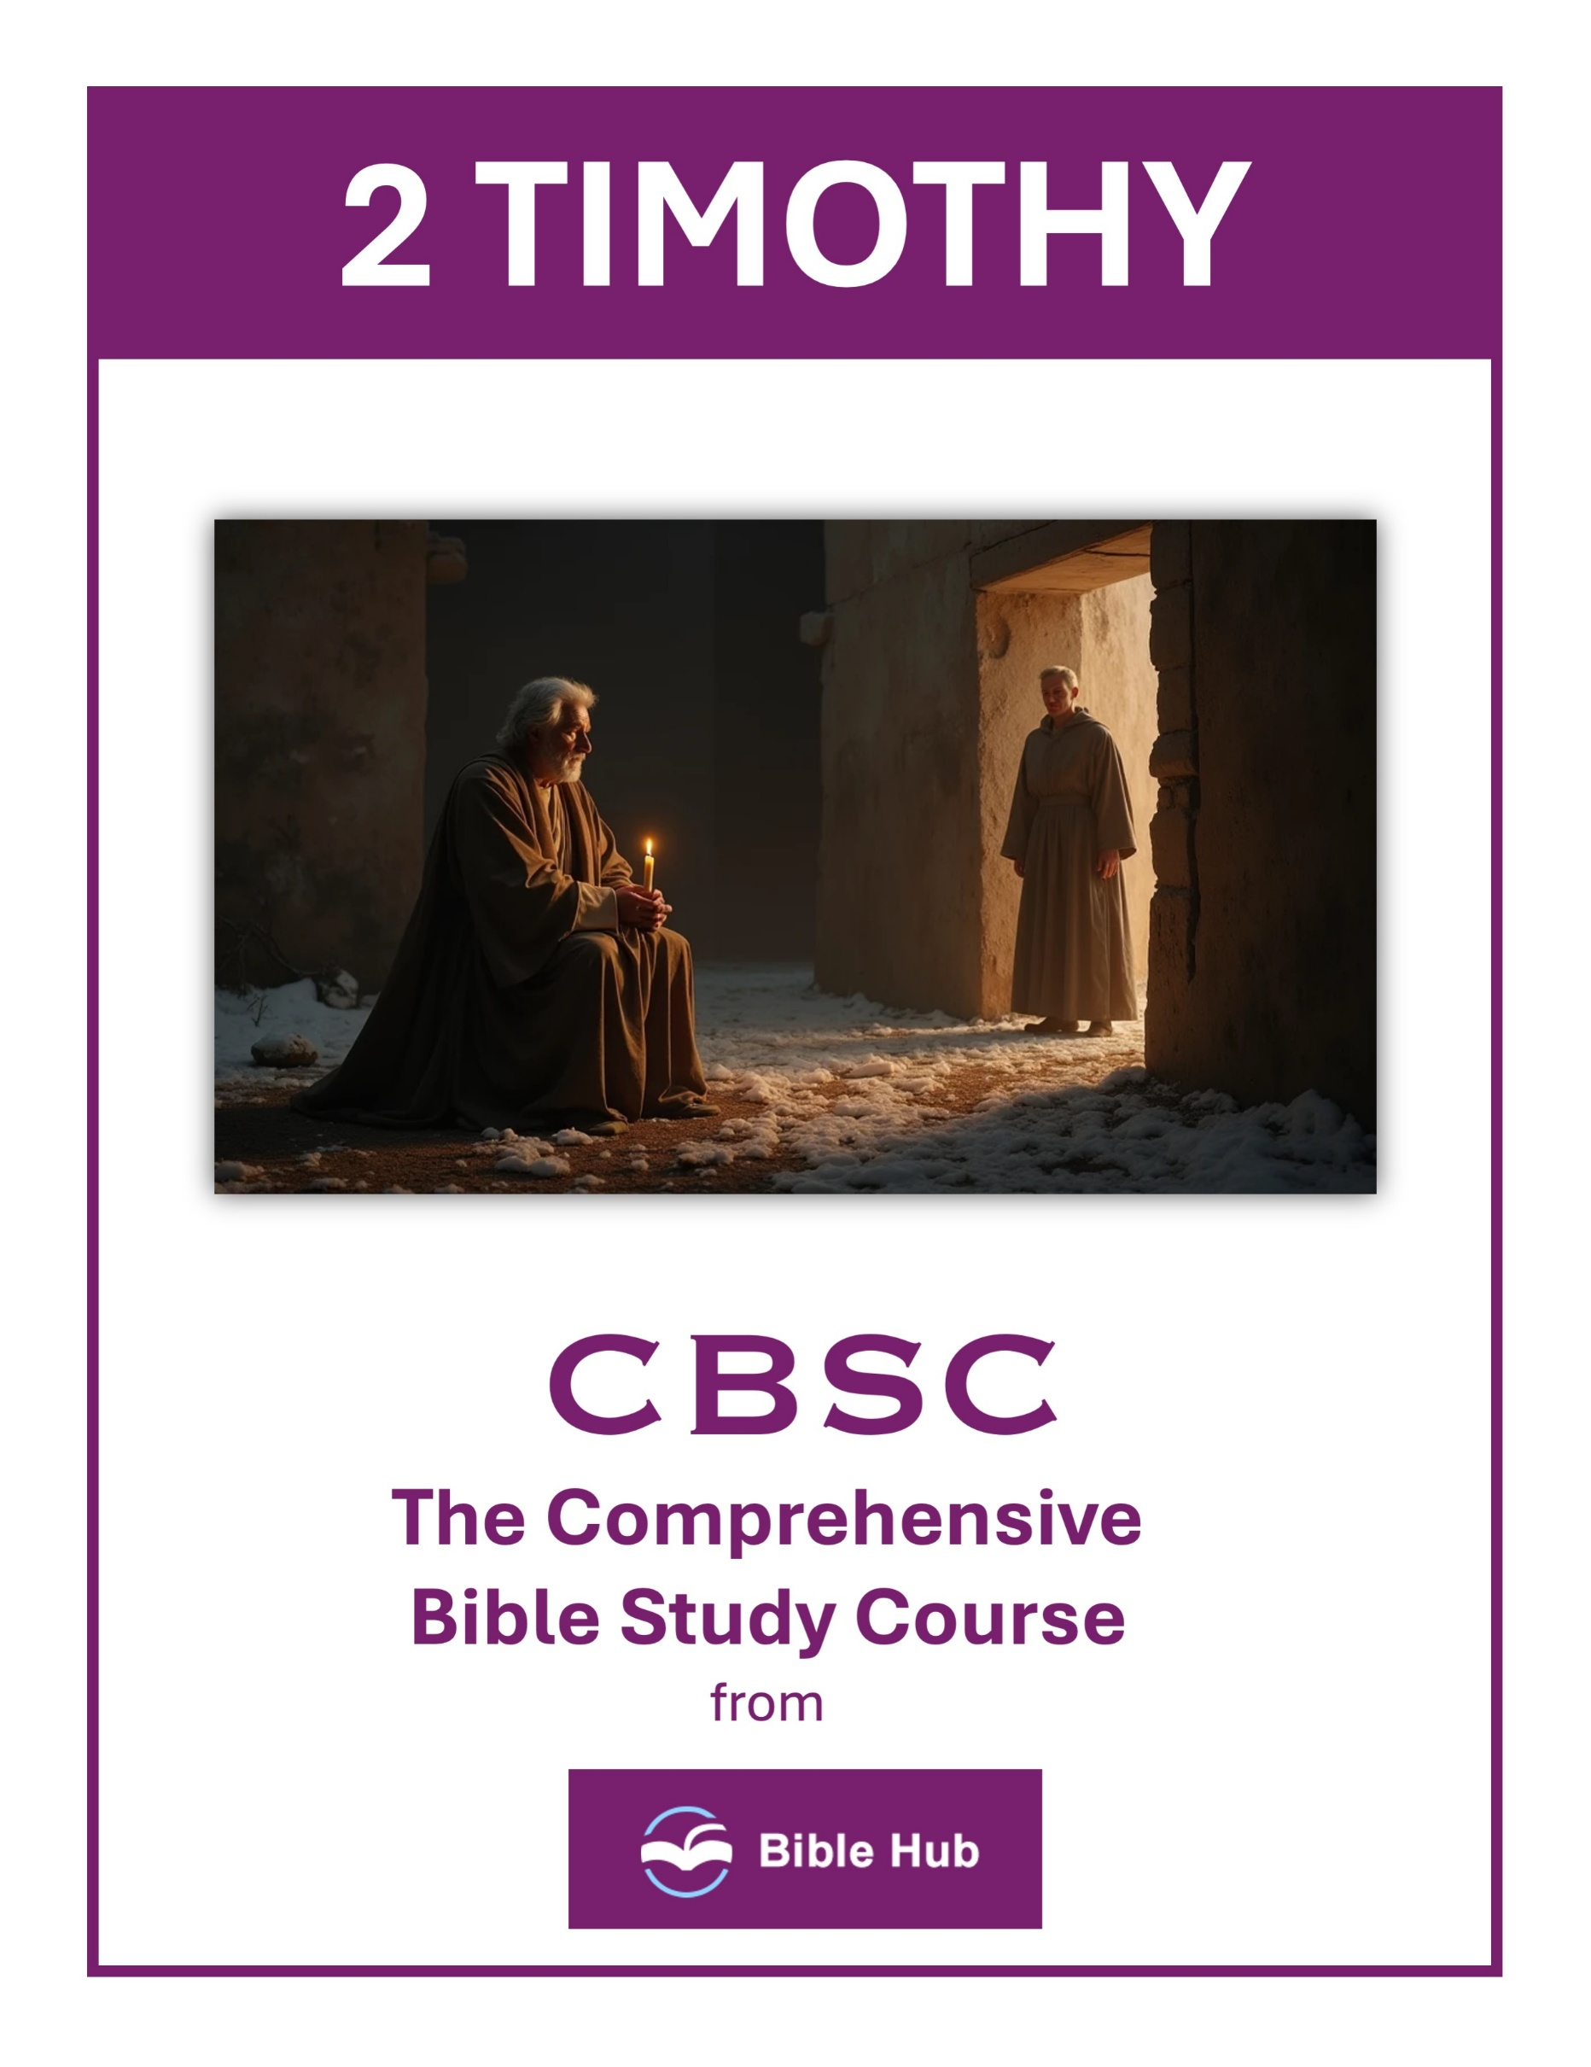

2 Timothy 1 Teaching Points and Bible Study Questions
Embrace Your Spiritual Heritage
In 2 Timothy 1:5, Paul reminds Timothy of the sincere faith that first lived in his grandmother Lois and his mother Eunice. This highlights the importance of recognizing and valuing the spiritual legacy passed down through generations. Whether you come from a long line of believers or are the first in your family to follow Christ, your faith journey is part of a larger story. Embrace it, nurture it, and let it guide you as you grow in your relationship with God.
1. How can you actively honor and continue the faith traditions passed down from your family?
2. Why do you think it's important to remember and embrace your spiritual heritage in daily life?
3. What steps can you take to strengthen and share your spiritual legacy with others?
Fan into Flame the Gift of God
Paul encourages Timothy in 2 Timothy 1:6 to "fan into flame the gift of God" that is within him. This is a call to actively cultivate and develop the spiritual gifts God has given you. Just as a fire needs tending to burn brightly, so do your gifts require attention and effort. Seek opportunities to use your talents for God's glory, and watch how He multiplies your efforts.
1. How can you actively nurture and develop the gifts God has given you in daily life?
2. Why do you think it's important to rekindle your spiritual gifts regularly?
3. What practical steps can you take to overcome fear and boldly use your God-given gifts?

Live with Power, Love, and Self-Discipline
In 2 Timothy 1:7, we are reminded that "God has not given us a spirit of fear, but of power, love, and self-discipline." This verse is a powerful reminder that as believers, we are equipped with everything we need to live boldly and confidently. Lean into the strength, compassion, and self-control that God provides, and let these qualities guide your actions and decisions.
1. How can you apply power, love, and self-discipline in challenging situations at work or school?
2. Why do you think self-discipline is essential for living a life of faith and love?
3. What practical steps can you take to cultivate love and power in your daily interactions?
Do Not Be Ashamed of the Gospel
Paul urges Timothy in 2 Timothy 1:8 not to be ashamed of the testimony about our Lord. In a world that often challenges or dismisses Christian beliefs, it's crucial to stand firm in your faith. Be proud of the gospel and the transformative power it holds. Share it with others, knowing that it is the truth that sets people free.
1. How can you overcome fear to share the Gospel in your daily life?
2. Why do you think some people feel ashamed of their faith in public settings?
3. What practical steps can you take to boldly proclaim your beliefs at work or school?

Join in Suffering for the Gospel
2 Timothy 1:8 also calls us to "join in suffering for the gospel by the power of God." This may seem daunting, but remember that suffering for the sake of Christ is a privilege and a testament to your commitment. When you face trials, rely on God's strength and know that your perseverance is a powerful witness to others.
1. How can you find strength to endure hardships for the Gospel in your daily life?
2. Why do you think sharing in suffering for the Gospel is important for spiritual growth?
3. What practical steps can you take to support others who are suffering for their faith?
Remember Your Holy Calling
In 2 Timothy 1:9, Paul reminds us that God "has saved us and called us to a holy calling." This is a profound truth that should shape your identity and purpose. You are set apart for God's work, and your life has a divine purpose. Seek to fulfill this calling with dedication and joy, knowing that you are part of God's grand plan.
1. How can you actively remember and embrace your holy calling in daily life?
2. Why do you think it's important to rely on God's power for your calling?
3. What steps can you take to overcome fear and fulfill your holy calling?

Trust in the Eternal Purpose of Christ
Paul speaks of the grace given to us in Christ Jesus before the beginning of time in 2 Timothy 1:9. This verse reassures us that God's plan for salvation is eternal and unchanging. Trust in His purpose and find peace in knowing that your salvation is secure in Christ, who has abolished death and brought life and immortality to light through the gospel.
1. How can you actively trust in Christ's eternal purpose during challenging times in your life?
2. Why do you think understanding Christ's eternal purpose strengthens your faith and daily decisions?
3. What practical steps can you take to align your goals with Christ's eternal purpose?
Guard the Good Deposit Entrusted to You
In 2 Timothy 1:14, Paul instructs Timothy to "guard the good deposit that was entrusted to you." This is a call to protect and preserve the truth of the gospel. Be vigilant in your study of Scripture, and hold fast to sound doctrine. Let the Holy Spirit guide you as you defend and share the faith with others.
1. How can you actively guard the faith and teachings entrusted to you in daily life?
2. Why do you think it's important to rely on the Holy Spirit to protect your beliefs?
3. What practical steps can you take to ensure you remain steadfast in your faith?

Be Strengthened by Grace
Paul's words in 2 Timothy 1:13 encourage us to "hold on to the pattern of sound teaching, with faith and love in Christ Jesus." This is a reminder that our strength comes from God's grace. Lean on His grace daily, allowing it to empower you to live out your faith with integrity and love.
1. How can you actively seek to be strengthened by grace in your daily challenges?
2. Why do you think grace is essential for enduring hardships in your life?
3. What practical steps can you take to rely more on grace rather than your own strength?
Find Encouragement in Fellowship
Finally, 2 Timothy 1:16-18 highlights the importance of fellowship and encouragement among believers. Paul speaks of Onesiphorus, who often refreshed him and was not ashamed of his chains. Surround yourself with fellow believers who uplift and support you in your walk with Christ. Together, you can encourage one another and grow stronger in your faith.
1. How can you find encouragement in fellowship when facing challenges in your faith journey?
2. Why do you think Paul emphasizes the importance of community in strengthening Timothy's faith?
3. What can you do to foster supportive relationships within your faith community?

2 Timothy 2 Teaching Points and Bible Study Questions
Be Strong in Grace
In 2 Timothy 2:1, Paul encourages Timothy to "be strong in the grace that is in Christ Jesus." This is a reminder that our strength doesn't come from our own abilities or efforts, but from the grace of God. Embrace this grace daily, allowing it to empower you to face challenges with confidence and peace. Remember, His grace is sufficient for you, and His power is made perfect in weakness.
1. How can you rely on grace to overcome challenges in your daily life?
2. Why do you think being strong in grace is essential for personal growth?
3. What practical steps can you take to strengthen your faith through grace?
Entrust to Faithful People
Paul instructs Timothy in verse 2 to "entrust these teachings to reliable men who will also be qualified to teach others." This highlights the importance of discipleship and passing on the truth of the Gospel. Invest in others who can continue the work of spreading the Good News, ensuring that the message of Christ reaches future generations.
1. How can you identify and entrust responsibilities to faithful people in your community or workplace?
2. Why do you think it's important to pass on teachings to reliable individuals?
3. What qualities do you hope to see in someone before entrusting them with important tasks?

Endure Hardship Like a Soldier
In verses 3 and 4, Paul compares the Christian life to that of a soldier, urging Timothy to "endure hardship" and not get entangled in civilian affairs. This metaphor reminds us to stay focused on our mission and to persevere through trials, keeping our eyes on the ultimate goal of pleasing our commanding officer, Jesus Christ.
1. How can you apply the discipline of a soldier to endure challenges in your daily life?
2. Why do you think enduring hardship is essential for spiritual growth and maturity?
3. What can you learn from a soldier's focus to help prioritize your spiritual commitments?
Compete According to the Rules
Verse 5 uses the analogy of an athlete who must "compete according to the rules" to win the prize. This teaches us the importance of integrity and discipline in our spiritual journey. Stay true to God's Word and His commandments, knowing that obedience leads to a victorious life in Christ.
1. How can you ensure you are "competing according to the rules" in your daily life?
2. Why do you think following rules is essential for spiritual growth and integrity?
3. What can you do when tempted to take shortcuts in your faith journey?

Work Hard Like a Farmer
Paul encourages Timothy in verse 6 to be like a hardworking farmer who "ought to be the first to partake of the crops." This lesson emphasizes diligence and patience in our spiritual endeavors. Just as a farmer waits for the harvest, we too must faithfully sow seeds of faith and trust God for the increase.
1. How can you apply a farmer's diligence and patience to your spiritual growth and daily life?
2. Why do you think perseverance is essential in both farming and your personal faith journey?
3. What can you learn from a farmer's commitment that could enhance your work ethic and relationships?
Remember Jesus Christ
In verse 8, Paul reminds Timothy to "remember Jesus Christ, raised from the dead, descended from David." This is the core of our faith—the resurrection of Christ. Keep this truth at the forefront of your mind, as it is the foundation of our hope and the assurance of our salvation.
1. How can you actively remember Jesus Christ in your daily routine and decision-making?
2. Why do you think remembering Jesus Christ is crucial during challenging times?
3. What practical steps can you take to keep Jesus Christ central in your relationships?

Endure for the Sake of the Elect
Paul speaks of enduring everything for the sake of the elect in verse 10. This teaches us the value of perseverance for the benefit of others. Our endurance can inspire and encourage fellow believers, helping them to remain steadfast in their faith.
1. How can you practically endure hardships to benefit and inspire those around you in your community?
2. Why do you think enduring challenges is essential for the growth and faith of others?
3. What can you do daily to strengthen your resolve to endure for the sake of others?
Avoid Quarreling About Words
In verse 14, Paul warns against "quarreling about words," which is "of no value and only ruins those who listen." Focus on what truly matters—the Gospel message—and avoid getting caught up in fruitless debates that distract from the truth.
1. How can you practice avoiding quarrels about words in your daily conversations and interactions?
2. Why do you think avoiding disputes over words is important for maintaining unity in relationships?
3. What steps would you take to refocus a conversation that is becoming a word-based argument?

Be a Worker Approved by God
Verse 15 encourages us to "present yourself approved to God, a worker who does not need to be ashamed and who correctly handles the word of truth." Strive to be diligent in studying Scripture, allowing it to guide your life and ministry, so you can stand confidently before God.
1. How can you ensure your work aligns with God's approval in your daily life?
2. What steps can you take to avoid distractions and stay focused on God's truth?
3. Why do you think diligence in studying scripture is crucial for being an approved worker?
Flee from Youthful Passions
Finally, in verse 22, Paul advises Timothy to "flee from youthful passions and pursue righteousness, faith, love, and peace." This is a call to live a life of holiness, turning away from temptations and focusing on virtues that reflect the character of Christ. Pursue these qualities with others who call on the Lord from a pure heart, building a community grounded in love and truth.
1. How can you identify and avoid youthful passions in your daily life?
2. Why do you think fleeing youthful passions is crucial for spiritual growth?
3. What practical steps can you take to pursue righteousness instead of youthful passions?

2 Timothy 3 Teaching Points and Bible Study Questions
Recognize the Times We Live In
In 2 Timothy 3:1, Paul warns, "But understand this: In the last days, terrible times will come." This is a call to be aware of the world around us. As believers, we should not be surprised by the challenges we face. Instead, we should be prepared and grounded in our faith, knowing that these times are part of a larger divine plan. Stay vigilant and let your faith be your guide.
1. How can you identify and respond to the challenges described in 2 Timothy 3 in today's world?
2. Why do you think it's important to recognize the signs of the times mentioned in 2 Timothy 3?
3. What practical steps can you take to remain faithful amidst the difficulties outlined in 2 Timothy 3?
Avoid the Pitfalls of Self-Centeredness
Paul describes people in the last days as "lovers of themselves, lovers of money, boastful, arrogant, abusive" (2 Timothy 3:2). This is a reminder to keep our focus on serving others and glorifying God, rather than being consumed by selfish desires. By putting others first, we reflect the love of Christ and stand out in a world that often prioritizes self-interest.
1. How can you identify and avoid self-centered behaviors in your daily interactions with others?
2. Why do you think self-centeredness is a common pitfall, and how can faith help overcome it?
3. What practical steps can you take to prioritize others' needs over your own desires?

Embrace Godliness Over Worldliness
In 2 Timothy 3:5, Paul speaks of those "having a form of godliness but denying its power." It's crucial to live authentically, letting our actions match our beliefs. True godliness is not just about appearances but about a heart transformed by the Holy Spirit. Seek to live a life that genuinely reflects the power and presence of God.
1. How can you prioritize godliness in daily decisions over worldly temptations?
2. Why do you think embracing godliness is challenging in today's society?
3. What practical steps can you take to cultivate godliness in your life?
Be Discerning About Influences
Paul warns Timothy to "have nothing to do with such people" (2 Timothy 3:5). This is a call to be discerning about the influences we allow into our lives. Surround yourself with those who encourage your faith and challenge you to grow spiritually. Choose your companions wisely, as they can either uplift or hinder your walk with Christ.
1. How can you identify and avoid negative influences in your daily life based on 2 Timothy 3?
2. Why do you think discernment is crucial when choosing role models or mentors according to 2 Timothy 3?
3. What practical steps can you take to ensure positive influences guide your decisions and actions?

Stand Firm in the Truth
In 2 Timothy 3:14, Paul encourages, "But as for you, continue in the things you have learned and firmly believed." In a world full of shifting values and beliefs, it's vital to stand firm in the truth of Scripture. Let the Word of God be your anchor, providing wisdom and guidance in every situation.
1. How can you apply 2 Timothy 3 to stand firm in truth amidst societal pressures?
2. Why do you think standing firm in truth is challenging in today's world?
3. What practical steps can you take to ensure you remain grounded in biblical truth daily?
Value the Power of Scripture
Paul reminds us that "All Scripture is God-breathed and is useful for instruction, for conviction, for correction, and for training in righteousness" (2 Timothy 3:16). The Bible is not just a book; it's a living guide that equips us for every good work. Make it a daily habit to immerse yourself in Scripture, allowing it to shape your thoughts and actions.
1. How can you apply the teachings of Scripture to overcome challenges in your daily life?
2. Why do you think Scripture is essential for personal growth and spiritual maturity?
3. What practical steps can you take to deepen your understanding and appreciation of Scripture's power?

Prepare for Persecution
Paul notes that "everyone who wants to live a godly life in Christ Jesus will be persecuted" (2 Timothy 3:12). While this may seem daunting, it's also a reminder that we are following in the footsteps of Christ. Take heart in knowing that persecution is a sign of your commitment to living out your faith boldly.
1. How can you strengthen your faith to endure persecution as described in 2 Timothy 3?
2. Why do you think Paul emphasizes perseverance in the face of persecution in this chapter?
3. What practical steps can you take to prepare for potential persecution in your daily life?
Be a Light in the Darkness
In a world described as "lovers of pleasure rather than lovers of God" (2 Timothy 3:4), we are called to be lights in the darkness. Let your life be a testament to the joy and peace that comes from a relationship with Christ. Shine brightly, so others may see your good deeds and glorify your Father in heaven.
1. How can you practically be a light in the darkness amidst the challenges listed in 2 Timothy 3?
2. Why do you think being a light is crucial when facing the behaviors described in 2 Timothy 3?
3. What can you do daily to ensure your actions reflect light in a world described in 2 Timothy 3?

Trust in God's Sovereignty
Despite the challenges outlined in 2 Timothy 3, we can trust in God's sovereignty. He is in control, and His plans are perfect. Rest in the assurance that God is working all things together for the good of those who love Him. Let this truth bring you peace and confidence as you navigate life's uncertainties.
1. How can you trust God's sovereignty when facing difficult situations described in 2 Timothy 3?
2. Why do you think trusting God's sovereignty is essential amidst the challenges listed in 2 Timothy 3?
3. What practical steps can you take to rely on God's sovereignty in your daily life?
Equip Yourself for Every Good Work
Finally, Paul concludes with the encouragement that Scripture equips us "so that the man of God may be complete, fully equipped for every good work" (2 Timothy 3:17). Embrace the tools God has given you through His Word, and be ready to serve Him in whatever capacity He calls you. With Scripture as your foundation, you are prepared to make a meaningful impact in the world.
1. How can you apply Scripture to equip yourself for challenges in your daily life?
2. Why do you think being equipped for good work is essential in your community?
3. What practical steps can you take to ensure you're prepared for every good work?

2 Timothy 4 Teaching Points and Bible Study Questions
Preach the Word with Urgency
In 2 Timothy 4:2, Paul exhorts Timothy to "preach the word; be prepared in season and out of season; correct, rebuke, and encourage with great patience and careful instruction." This is a call to action for all believers to share the Gospel with urgency and readiness. Whether the time seems right or not, the truth of Christ's resurrection and salvation must be proclaimed. Let this be a reminder to seize every opportunity to share the Good News, knowing that the Word of God is living and active.
1. How can you incorporate urgency in sharing your faith in everyday conversations?
2. Why do you think it's important to be prepared to preach the Word at all times?
3. What practical steps can you take to remain steadfast in your mission despite challenges?
Stand Firm Against False Teachings
Paul warns in 2 Timothy 4:3-4 that "the time will come when men will not tolerate sound doctrine." Instead, they will gather teachers who say what their itching ears want to hear. This is a powerful reminder to hold fast to the truth of Scripture, discerning and rejecting teachings that deviate from the Gospel. Equip yourself with the Word, so you can stand firm against deception and guide others back to the truth.
1. How can you discern and resist false teachings in your daily life and community?
2. Why do you think standing firm against false teachings is crucial for your faith journey?
3. What practical steps can you take to strengthen your understanding of true doctrine?

Fulfill Your Ministry
In 2 Timothy 4:5, Paul encourages Timothy to "keep your head in all situations, endure hardship, do the work of an evangelist, fulfill your ministry." Each of us has a unique calling and purpose in God's kingdom. Embrace your role with diligence and perseverance, knowing that your labor in the Lord is not in vain. Whether your ministry is in the church, your workplace, or your home, fulfill it with passion and faithfulness.
1. How can you identify and fulfill your ministry in your current life situation?
2. What steps can you take to remain faithful in your ministry despite challenges?
3. Why do you think perseverance is crucial in fulfilling your ministry?
Embrace the Reality of Spiritual Warfare
Paul's life was a testament to the spiritual battles believers face. In 2 Timothy 4:7, he declares, "I have fought the good fight, I have finished the race, I have kept the faith." Recognize that following Christ involves spiritual warfare, but take heart in knowing that victory is assured through Him. Equip yourself with the armor of God and remain steadfast in faith, knowing that the Lord is your strength and shield.
1. How can you stay vigilant in recognizing spiritual warfare in your daily life?
2. What practical steps can you take to support others facing spiritual battles?
3. Why do you think perseverance is crucial in overcoming spiritual challenges?

Look Forward to the Crown of Righteousness
Paul speaks of the "crown of righteousness" in 2 Timothy 4:8, which the Lord will award to all who have longed for His appearing. This promise is a source of hope and motivation for believers. Keep your eyes fixed on the eternal reward that awaits, and let it inspire you to live a life of righteousness and devotion to Christ. The trials of this world are temporary, but the glory to come is everlasting.
1. How can you actively prepare yourself to receive the crown of righteousness in your daily life?
2. What do you hope to change in your life to align with the promise of the crown?
3. Why does anticipating the crown of righteousness motivate you to persevere through challenges?
Value Godly Companionship
In 2 Timothy 4:11, Paul mentions, "Only Luke is with me." This highlights the importance of godly companionship in our spiritual journey. Surround yourself with fellow believers who will support, encourage, and hold you accountable. Together, you can strengthen one another in faith and spur each other on toward love and good deeds.
1. How can you prioritize godly companionship in your daily life, as Paul did with his companions?
2. Why do you think Paul valued the presence of certain companions during his ministry challenges?
3. What steps can you take to cultivate and maintain meaningful relationships with fellow believers?

Forgive and Move Forward
Paul's request in 2 Timothy 4:16, "May it not be held against them," regarding those who deserted him, is a powerful lesson in forgiveness. Holding onto grudges can hinder your spiritual growth and ministry. Instead, choose to forgive as Christ forgave you, freeing yourself to move forward in your walk with God and your service to others.
1. How can forgiving others help you move forward in your personal and spiritual growth?
2. Why do you think Paul emphasizes forgiveness despite being deserted by others?
3. What steps can you take to forgive and release past grievances in your life?
Trust in the Lord's Deliverance
Paul confidently states in 2 Timothy 4:18, "The Lord will rescue me from every evil deed and will bring me safely into His heavenly kingdom." Trust in God's deliverance and protection, knowing that He is faithful to His promises. No matter the challenges you face, rest assured that the Lord is with you, guiding and sustaining you through every trial.
1. How can you apply trust in the Lord's deliverance during challenging times in your life?
2. Why do you think Paul emphasizes God's deliverance despite facing hardships and opposition?
3. What can you do to strengthen your faith in God's deliverance in everyday situations?

Prioritize Scripture in Your Life
Paul's emphasis on Scripture throughout his letters, including 2 Timothy, underscores its importance. Make the Word of God a priority in your daily life, allowing it to guide your decisions, shape your character, and deepen your relationship with Christ. As 2 Timothy 3:16-17 reminds us, "All Scripture is God-breathed and is useful for teaching, rebuking, correcting, and training in righteousness."
1. How can you prioritize Scripture daily amidst your busy schedule, as Paul advises Timothy in 2 Timothy 4?
2. Why do you think Paul emphasizes the importance of Scripture in facing challenges and staying grounded?
3. What practical steps can you take to ensure Scripture guides your decisions and actions?
Finish Strong in Faith
Paul's life and words in 2 Timothy 4 serve as an inspiring example of finishing strong in faith. He remained faithful to the end, despite trials and persecution. Let his example encourage you to persevere in your own faith journey, keeping your eyes on Jesus, the author and perfecter of our faith. As you run the race set before you, remember that the Lord is with you every step of the way, empowering you to finish strong.
1. How can you apply Paul's perseverance to finish strong in your own faith journey today?
2. What steps can you take to guard your faith against distractions and challenges?
3. Why do you think finishing strong in faith is important for your personal spiritual growth?

